[1]

16-Step Sequencer and Synthesizer

林卓文，11510818 郭锦岳，11510478

# Introduction

T

# Procedures

# Audio Synthesizer

The aim of audio synthesizer is to generate the output waveform of audio signal, it has to be a frequency-adjustable waveform generator, which takes input tone controlling signal and outputs the corresponding waveform. Also, according to the manual of Nexys 4 DDR board, we applied a Pulse Width Modulator (PWM) in order to implement the DAC process.

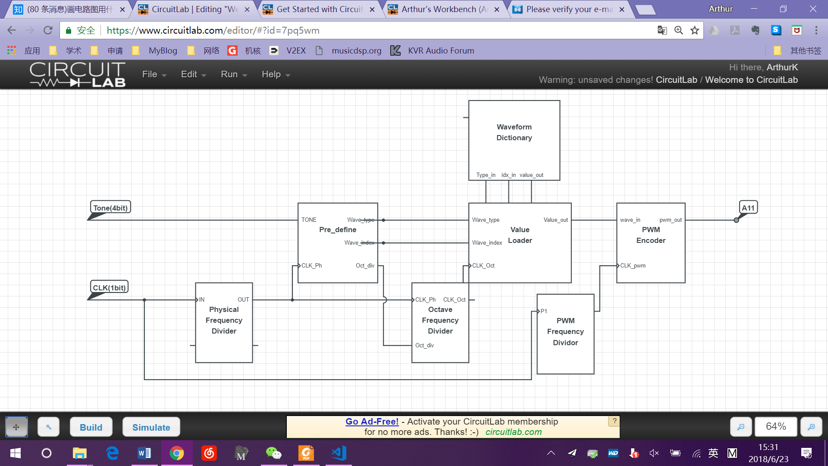

## Physical Frequency Divider

This divider takes the board CLK as input, and reduces the frequency into hearable frequencies. The dividing coefficient is counter_phys_max = 46. It can turn the output waveform matches their standard frequencies as below:

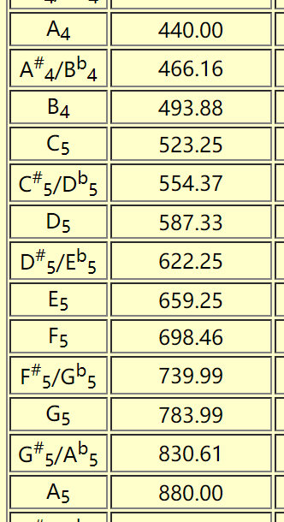

## Pre-definder

It determines three coefficients, according to the input 4-bit tone signal.

There are five waveforms saved in the waveform dictionary, which are all 512-length arrays. We chose the pentatonic tones as our waveforms, namely C, D, E, G and A.

Signal *wave* determines which of these five arrays will be loaded.

Signal *max_index* determines the corresponding loading range. Since the 512-length array is not a whole period, we only takes the first period as our output value. *Max_index* is different for all five dictionaries.

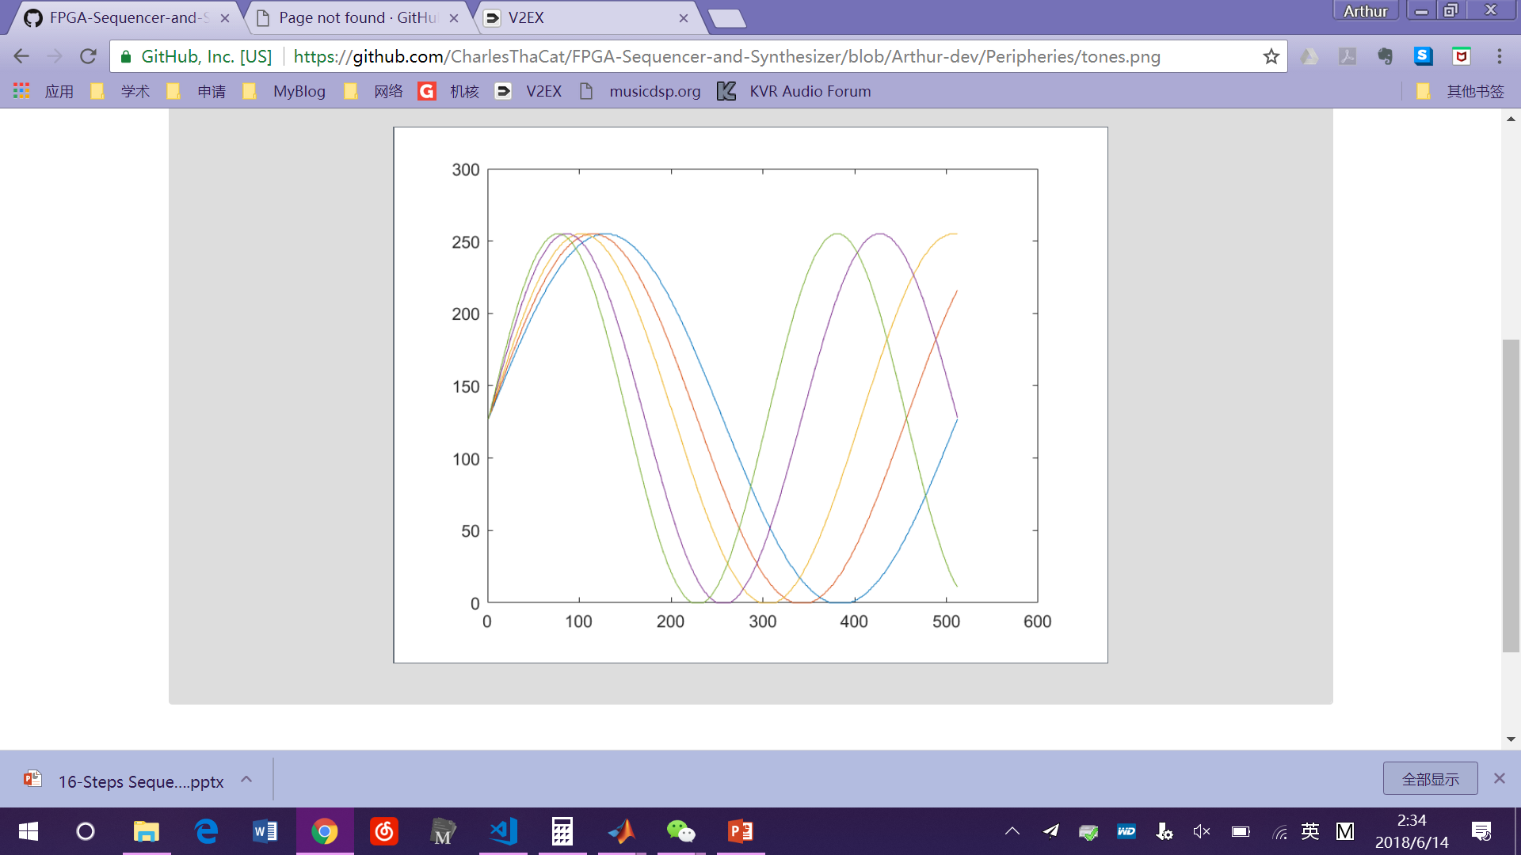

Figure : Five arrays in the waveform dictionary.

|  |  |
| --- | --- |
| **Tone** | **Max_index** |
| C | 511 |
| D | 455 |
| E | 407 |
| G | 342 |
| A | 305 |

Signal *counter_div_max* determines the octave frequency divider coefficient. Since C5 has the half frequency of C6, and C4 has the half frequency of C5, we can generate tones of different octaves by dividing the frequency of C6 into 1/2 or 1/4

## Octave Frequency Divider

It takes the physical CLK signal as input CLK, and

further divides it by the octave divider coefficient.

## Output Value loader

It will load the value according to *wave* and *max_index* generated by *B.* The loading frequency is the octave-divided frequency generated by *C.*

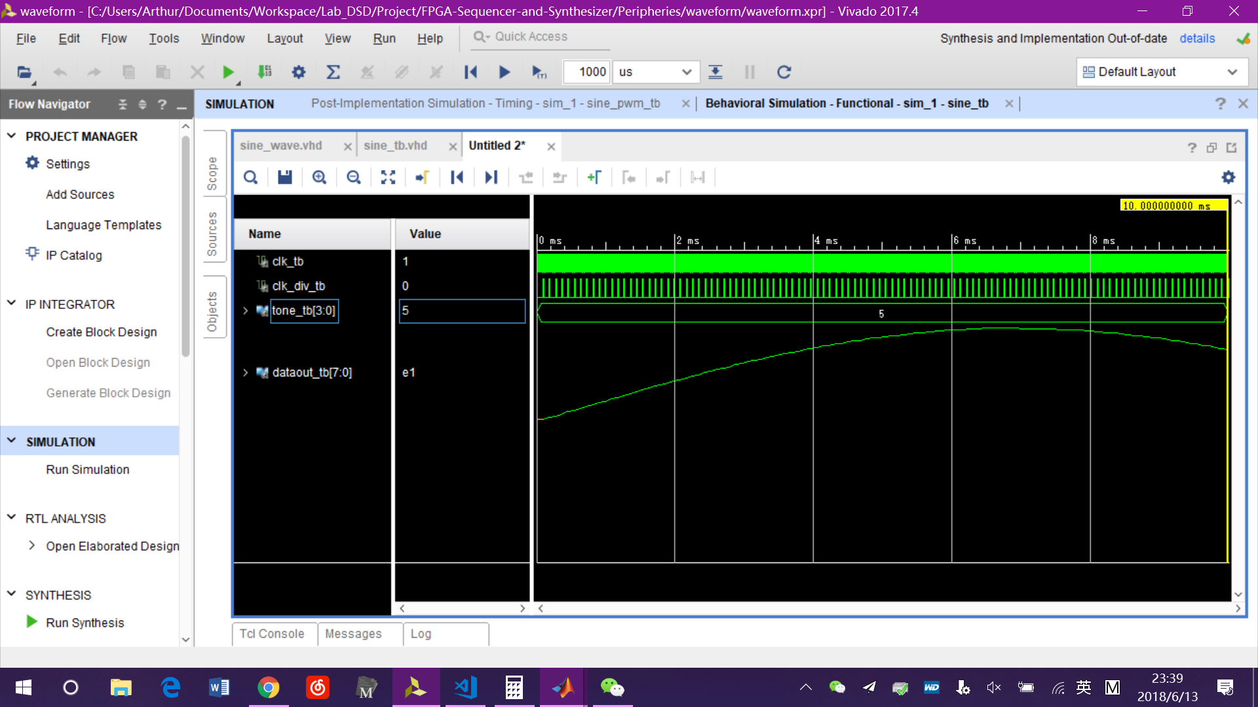

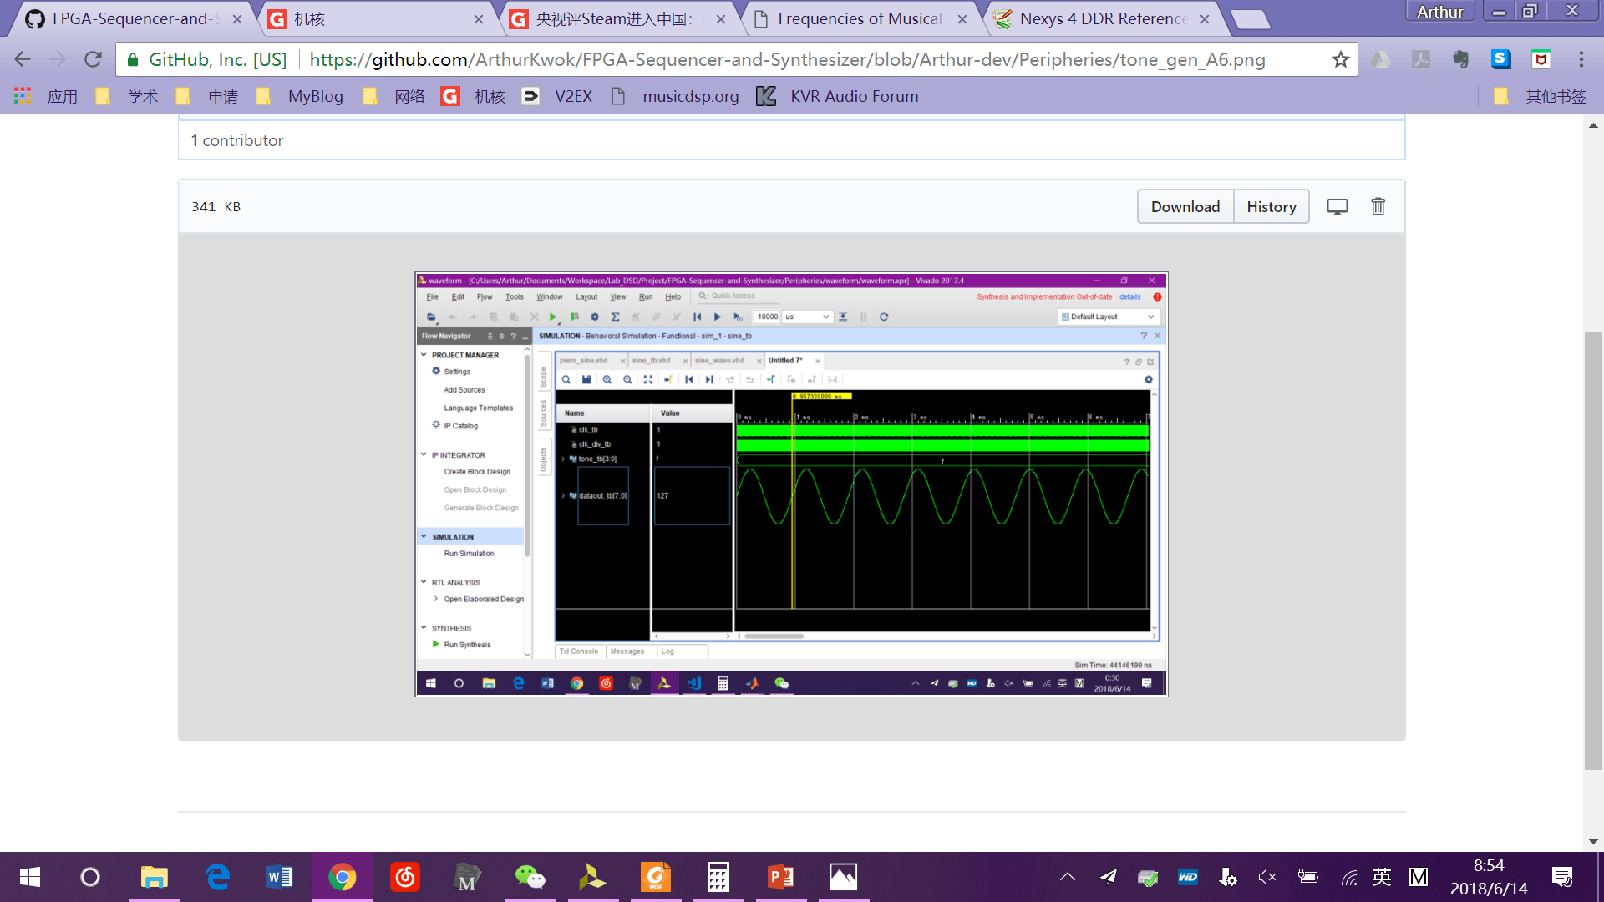

Figure :Output waveform of A4 (above) and A6 (below), A6 is four times of A4.

## PWM Frequency Divider

Determines the frequency of PWM encoder. This is the actual sampling frequency, so generally it should be greater than 44.1 kHz in order to cover the frequency range of hearing.

Even though the board manual says that PWM frequency should be as high as possible, we find out that the output volume will be extremely low if the PWM frequency is too high. This is due to the property of the LPF circuit before the output jack on the board.

The final coefficient as 2048, which makes the sampling frequency equals to 48.828 kHz. We think it is the best choice to make the output signal achieves the best sound quality as well as acceptable volume.

## PWM Encoder

Generates the binary output waveform according to the input 8-bit value.

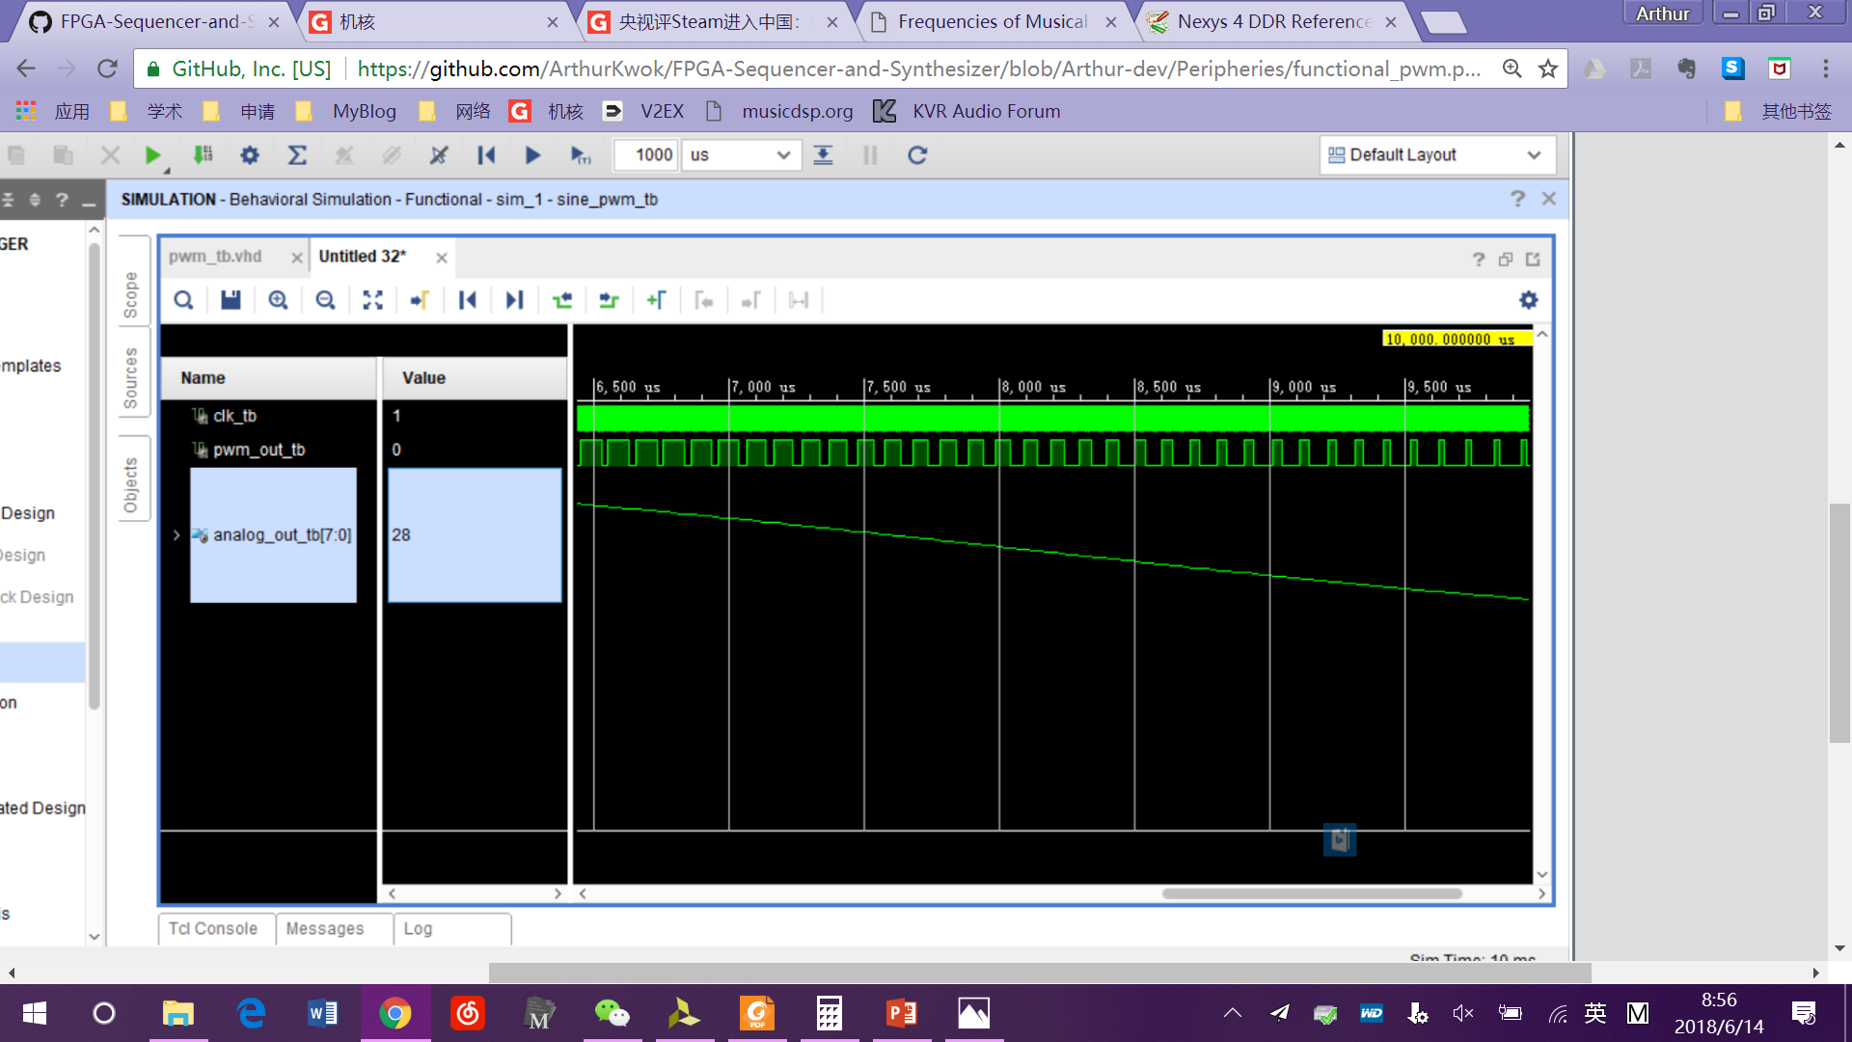

Figure : Output waveform of PWM encoder

In the post-implementation timing synthesis, we have found that the 8-bit waveform has some noise, which might because of the flip-flop error in *D.* But the PWM encoder has the function of a down sampler, thus it could some-how reduce the output noise.

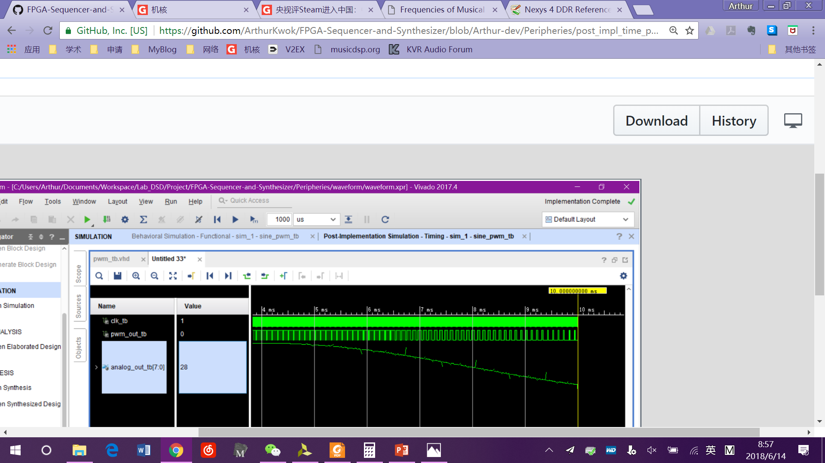

Figure : Post-implement timing synthesis of PWM encoder. The transient error of analog output has been reduced.

The output signal of PWM encoder is directly connected to the pin of speaker.

References

1. J. S. Turner, “New directions in communications,” *IEEE J. Sel. Areas Commun*., vol. 13, no. 1, pp. 11-23, Jan. 1995.
2. W. P. Risk, G. S. Kino, and H. J. Shaw, “Fiber-optic frequency shifter using a surface acoustic wave incident at an oblique angle,” *Opt. Lett.*, vol. 11, no. 2, pp. 115–117, Feb. 1986.

1.